**Title**

Author #1 a,b, **Presenting Author** a, Author #2 c, Author #3 a,b….

a Affiliation #1

b Affiliation #2

c Affiliation #1

* presenting_author@email.com

Abstracts are brief summaries of the overall goal of the research, showing the specific ideas or concepts that will be presented, including outcomes and implications for practice. Please use ARIAL 10 as Font and size.

**Authors:** underline anduse bold letters for the presenting author. Names with initials, complete surname.

**Please limit abstracts to one single page. Do not change page layout**

Include **maximum 1 images** with your abstract **(limited to a third of the page length)**.

**References are optional but encouraged**. Please limit references to the 5 most pertinent citations at the end of the document. Refer to them with a number between brackets.

Notification of acceptance will be done to the presenting author email address.

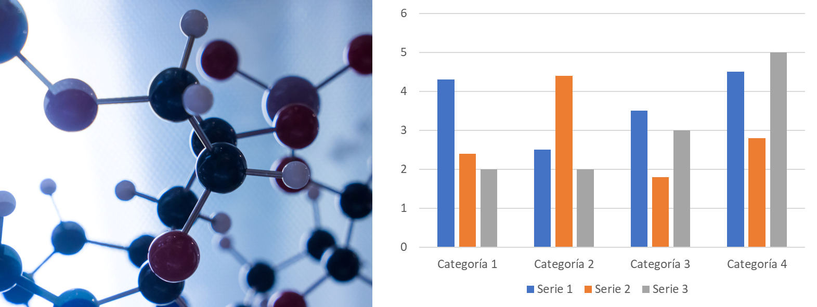

*Figure -* Description of the image

**References**

[1] Authors, Journal, vol, pag (year)

(Preferred oral or poster contribution)